Analysis of Algorithms and Data Structures: Classic Sudoku
Yong-Jin Lee
CSC506
CSU Global
Isaac Gang, Instructor
11/6/2022

Abstract
Objective: Sudoku has more than six sextillion possible solvable grids each with its unique result. The purpose of this study was to determine the effectiveness of solving classic sudoku problems through backtracking, integer linear programming, and constraint programming.
Methods: Analyzing these algorithms required the following tools: Kaggle Notebooks, Notepad++, and Python 3.10. Kaggle Notebooks is a cloud computational environment. Notepad ++ is a versatile, open-source text and source code editor. Python 3.10 is a virtual environment that supports multiple programming paradigms, making use of its object-oriented, high-level programming language with dynamic semantics. The algorithms required the use of many Python modules like NumPy, pandas, datetime, and copy. These modules help process arrays, utilize high-performance data structures and data analysis tools, calculate execution times, and use deep copies so that changes made on the copy are not the same in the original object, respectively. The tqdm library and ortools suite are also used to provide progress bars and conduct integer linear and constraint programming. Algorithms for integer linear programming and constraint programming from Thiego Oliveira (2019) were adjusted to produce the results in Figures A1 and A2. Analyses included practical comparisons and examination of execution times of the three algorithms.
Conclusion: After executing each algorithm in five iterations one thousand times, the average execution times for integer linear programming, constraint programming, and backtracking were observed to be the following in seconds: 0.0095608, 0.0022662, and 0.0380682, respectively. The execution times were also recorded when five iterations were run again but ten thousand times each. They were 0.0097346, 0.0019164, and 0.3833918 seconds. Both integer linear and constraint programming grew increasingly more efficient as the number of repetitions increased by a factor of 10. The gap in execution times between integer linear programming and backtracking expands from a ratio of 3.98 to 39.38.
Background
Leonard Euler, a Swiss mathematician, came up with ‘Latin Squares’ in 1783 which consisted of a grid in which every number or symbol appears once in each row or column.
These puzzles would eventually be known as Sudoku puzzles in which each one is composed of 9 non-overlapping blocks, each holding 3 rows and 3 columns. As a constraint satisfaction problem, the goal of each puzzle is to provide the remaining empty elements in the grid without repeating a number from 1 to 9 in each row and column. The difficulty is mainly determined by how many such elements are initially provided. Such puzzles can be mathematically ranked through the Ercsey-Ravasz and Toroczkai (ERT) scale from 1 to 4 where 1 represents beginner and 4 indicates those of the highest difficulty. The pair believed that the behavior of algorithms that solve these puzzles, being “the twists and turns that it follows through state space - is a good measure of the difficulty of the problem” (Emerging Technology from the arXiv, 2012, para. 8). Although no puzzle is known to have a difficulty rating of 4, the most complex one has been coined as ‘the platinum blond’ which has a difficulty of 3.5789. Sudoku also has multiple variations of increasing grid size, unique diagonal cells, and sums of values within regions; however, this project will focus on the classic version of Sudoku.
Class Sudoku presents itself as an NP-complete problem, making it possible to be reduced into a Hamiltonian cycle problem. Such a cycle that can be placed as “a simple graph (that is, one containing self-loops or multi-edges) containing vertex set V and edge set E: V -> V, determine whether any simple cycle containing all vertices in V exist in the graph” are called Hamiltonian cycles (Haythorpe, 2016, p. 273). Although this concept was named after Sir William who put together a puzzle to determine a path along the polyhedron edges of a dodecahedron, it continues to hold real-world applications. Electronic circuit design, genome mapping, and operations research have been made possible. Scientists need to construct a Hamiltonian cycle so that many fragments of genetic code can be amalgamated into a single genomic sequence.
Algorithms
Backtracking
Backtracking is a brute force algorithm that solves problems by “trying to build a solution incrementally, one piece at a time, removing those solutions that fail to satisfy the constraints of the problem at any point of the time” (Introduction to Backtracking - Data Structure and Algorithm Tutorials, 2018, para. 1). It conducts a depth-first search into the variable assignment tree where each cell is a set of assignments. Out of the three types, this method will solve the puzzle as a decision problem that focuses on looking for a feasible solution. This approach is often utilized as a last resort to guessing passwords but is also used in data dredging to search for statistically significant patterns in data.
The specific algorithm used will initially either make a copy of a grid or generate a new grid before proceeding to solve it. To ensure a valid puzzle is made, removed numbers are checked so it does not repeat itself in the row, column, and subgrid. The validLocation() method is set to check if the value does not repeat in the given position after each removed number is evaluated first. This function is used to solve the puzzle that was created until all the removed numbers have been solved. The next function then would print the solution of the puzzle until every position satisfies the validLocation() method. To finish creating the puzzle, a list of non-empty squares is determined by shuffling and a pop() method is used to remove numbers from the grid. Once these two processes are set, the timeit module is used to time the entire algorithm to both 1000 and 10000 iterations. To generate and solve the puzzles, thirteen functions through the def keyword, sixteen decision-making statements with the if keyword, and fourteen loops with the for keyword were required.
Integer Linear Programming
Integer linear programming branches from linear programming, an optimization model that is built upon the objective function, decision variables, and constraints. The decision variables consist of the cells in each grid and the nine possible numbers for each cell. The constraints in Sudoku include how each row, column, and three by three grid is limited to one set of numbers from 1 to 9. This technique has many applications including but not limited to: “production scheduling, inventory policies, investment portfolio, allocation of advertising budget, construction of warehouses, etc” (Maiti, 2020, para. 2). Because only a feasible solution is required, this algorithm will not need an objective function. The decision variables (1) are defined as the following (Bartlett et al., 2008, p. 3):
$x_{ijk}=$ | { | $1,$  $0,$ | $if element (i, j) of the n x n Sudoku matrix contains the integer k$ (1)  otherwise.
Both algorithms for integer linear and constraint programming depend on NumPy, pandas, and datetime modules and three methods to decode, encode, and solve the puzzle. The methods are necessary because the input comes from the dataset saved as sudoku.csv (Vopani, 2019). With the pywraplp module, the three variables i, j, and k are initialized before setting the condition that each cell can only have 1 unique value from the grid size of 9. The variables are then differentiated between all rows, columns, and regions. Unless the sudoku is deemed impossible to resolve, then the execution time is printed. When comparing execution times, the sample size was adjusted to accommodate 10,000 when run through the Kaggle console. Unlike backtracking, these two algorithms used significantly fewer methods and decision-making statements. Twenty-three loops were still needed throughout the two main methods for each separate algorithm.
Constraint Programming
Constraint programming (CP) functions by specifying “the problem in terms of decision variables, their domains describing possible values to be assigned to the variables, and finally, constraints, restricting possible combinations of values” (Barták, 2008, p, 123). CP has become well-implemented in analyzing DNA structure, time-tabling for hospitals, and industry scheduling.
Despite sharing components with the previous algorithm, the constraint programming algorithm first creates and instantiates just two variables of i and j. Then for loops are set constraints on each column(1), row(2), and region(3) to be all different (Crawford et al., 2009, pp. 346 - 347).
$∀i_{} ∈ \{1, ..., 9\} Alldifferent\{x_{i1}, x_{i2}, ..., x_{i9}\}$ (1)
$∀i_{} ∈ \{1, ..., 9\} Alldifferent\{x_{1j}, x_{2j}, ..., x_{9j}\}$ (2)
$∀i_{} ∈ \{1, ..., 9\} Alldifferent\{x_{ij},x_{i(j+1)},x_{i(j+2)}, x_{(i+1)j},$ (3)
$x_{(i+1)(j+1)}, x_{(i+1)(j+2)},x_{(i+2)j}, x_{(i+2)(j+1)}, {x_{(i+2)(j+2)}}_{}\}$
$con i = k*3+1 y j=l*3+1.$
The timer is set to print the execution time unless the sudoku puzzle cannot be solved.

Analysis
The time complexity for the backtracking algorithm is O(9N) at both the worst and average case where N represents every unfilled cell. The best-case time complexity would stand at O(N2). The change in execution time between the two figures A1 and A2 has a factor of 10. Although its size is more than half as large as the latter algorithms, it did not require a separate dataset to be able to produce a puzzle. Because there are only N function calls in the recursion stack, the space complexity will be O(n2).
The integer linear programming algorithm runs at the time complexity of O(n3*log(n)). Based on the average execution time between the results displayed in figures A1 and A2, the change observed when the input size was increased by a factor of 10 was about 1.82 percent. Its space complexity will also be O(n3) because a three-dimensional array is utilized.
The time complexity for constraint programming also came out to be O(n2*log(n)). The average execution time decreased by about 15 percent when the sample size was increased. This algorithm has a space complexity of O(n2) as a two-dimensional matrix was needed.

References
Barták, R. (2008). Rina Dechter Constraint Processing 2003 Morgan Kaufmann Publisher 1-55860-890-7 xx+481; Francesca Rossi Peter van Beek Toby Walsh Handbook of Constraint Programming 2006 Elsevier 978-0-444-52726-4 xix+955. Computer Science Review, 2(2), 123–130. https://doi.org/10.1016/j.cosrev.2008.05.001
Bartlett, A. C., Chartier, T. P., Langville, A. N., & Rankin, T. D. (2008). An Integer Programming Model for the Sudoku Problem. The Journal of Online Mathematics and Its Applications, 8, 1798. https://www.maa.org/external_archive/joma/Volume8/Bartlett/index.html
Crawford, B., Castro, C., & Monfroy, E. (2009). Solving Sudoku with Constraint Programming. Communications in Computer and Information Science, 345–348. https://doi.org/10.1007/978-3-642-02298-2_52
Emerging Technology from the arXiv. (2012, August 6). Mathematics of Sudoku leads to “Richter scale” of puzzle hardness. Technology Review. https://www.technologyreview.com/2012/08/06/18948/mathematics-of-sudoku-leads-to-richter-scale-of-puzzle-hardness/
Haythorpe, M. (2016). Reducing the generalised Sudoku problem to the hamiltonian cycle problem. AKCE International Journal of Graphs and Combinatorics, 13(3), 272–282. https://doi.org/10.1016/j.akcej.2016.10.001

Introduction to Backtracking - Data Structure and Algorithm Tutorials. (2018, July 23). GeeksforGeeks. https://www.geeksforgeeks.org/introduction-to-backtracking-data-structure-and-algorithm-tutorials/
Maiti, A. (2020, November 19). Applications of Linear Programming Problem (LPP). Towards Data Science. https://towardsdatascience.com/applications-of-linear-programming-problem-lpp-385bc3bb9621
Oliveira, T. (2019, December 22). Modeling a Sudoku Solver with OR Tools [Source Code]. Kaggle. Retrieved November 2, 2022, from https://www.kaggle.com/code/pintowar/modeling-a-sudoku-solver-with-or-tools/notebook
Vopani. (2019). 9 Million Sudoku Puzzles and Solutions [Data set]. https://www.kaggle.com/datasets/rohanrao/sudoku

Appendix A
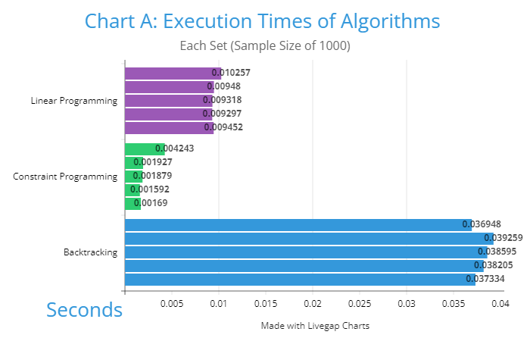
Figure A1: Execution Times of Algorithms A - This figure shows the five iterations of execution times gathered from each algorithm. Each iteration has a sample size of 1000.

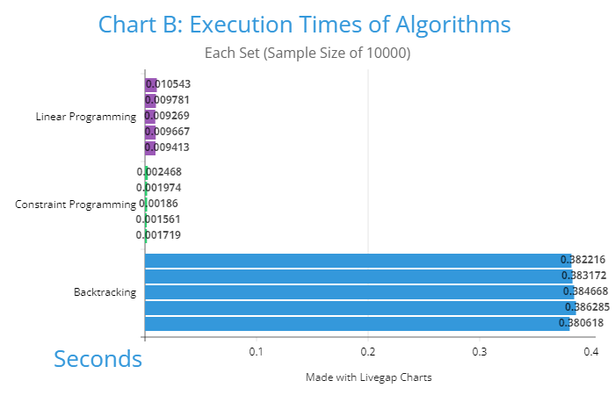
Figure A2: Execution Times of Algorithms B- This figure shows the five iterations of execution times gathered from each algorithm. Each iteration has a sample size of 10000.

